**Spectral Rolloff:**

The spectral Rolloff provides information about the overall shape and spread of energy in the spectrum. If the spectral Rolloff is at a lower frequency, it suggests that a larger portion of the energy is concentrated in the lower frequencies. Conversely, if the spectral Rolloff is at a higher frequency, it indicates that the energy is spread across higher frequencies.

* **Recognition:** Spectral Rolloff can be utilized in speech and speaker recognition tasks.
* **Audio Effects:** Spectral Rolloff can be employed in audio effects processing to control the high-frequency content of a sound.
* **Speech and Speaker Recognition:** Different speakers and speech sounds may exhibit distinct Rolloff characteristics, aiding and identifying different speaker voice textures.

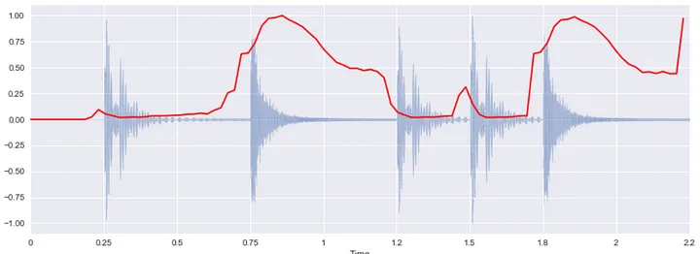

It’s a measure of the frequency content of a signal. It is calculated by finding the frequency below which a specified percentage of the total spectral energy lies. For example, a spectral Rolloff of 85% means that 85% of the total spectral energy lies below a certain frequency.